THIS MARKER BASED AR IS DEVELOPED USING UNITY AND VUFORIA BY CREATING AN ASSET USING BLENDER .

MARKER:



CREATED ASSET:

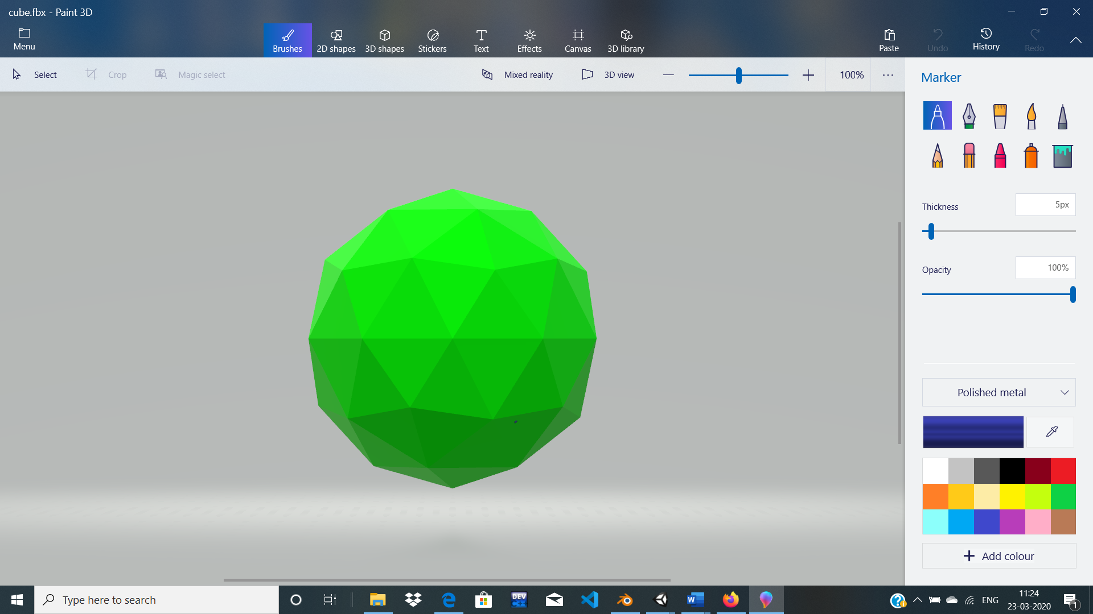

SCEENSHOT:

